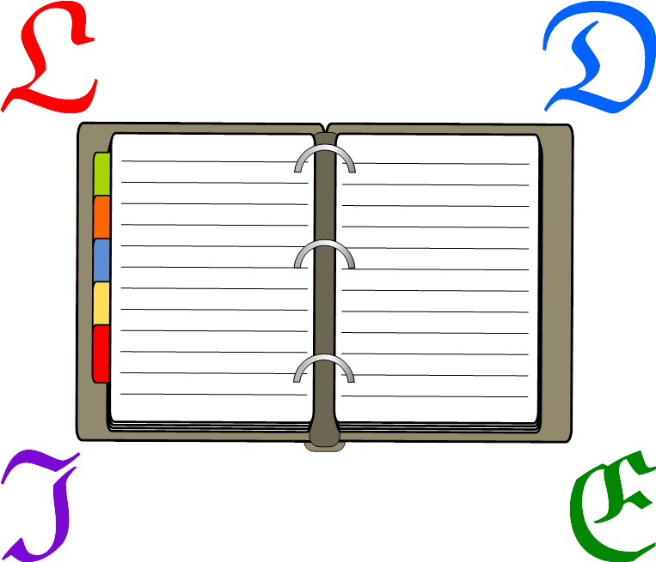
Literature Done in English

Douglas Perkins & Adam Pearson
January 9, 2016

Preface

“Who alive can say, 'Thou art no Poet may'st not tell thy dreams?'”
– John Keats, “The Fall of Hyperion” (1819)

“What really knocks me out is a book that, when you're all done reading it, you wish the author that wrote it was a terrific friend of yours and you could call him up on the phone whenever you felt like it. That doesn't happen much, though.”
– J. D. Salinger, “The Catcher in the Rye” (1951)

“What the Imagination seizes as Beauty must be truth—whether it existed before or not...”
– John Keats, “To Benjamin Bailey” (1817)

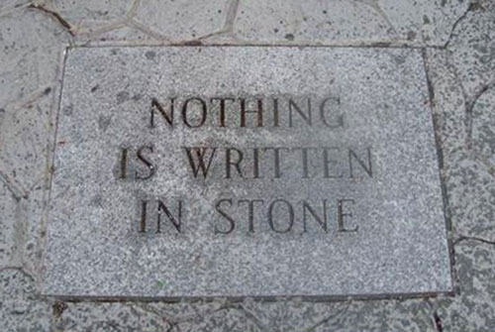 | 

The study of English literature has numerous benefits. When studying poetry, students learn about syllables, sounds, and how to choose between words that have similar meanings yet differ in nuance. Taking a glance at prose gives students a look at what some great historical authors had to say and how the way these authors expressed themselves lent significance to their messages.

This short textbook was first written in December, 2015, for a two-month segment of a tenth grade ESL class in Japan. Our students are planning to study abroad their 11th grade year, and in preparation for English class while abroad we study a little bit before they go. Two months is a short time for such a vast field. Yet, if our students develop some appreciation for English literature, it will surely be a benefit to them. Hemingway once wrote, “There are many kinds of stories in this book. I hope that you will find some that you like.”

This book is freely licensed in the hope that other teachers will, if they like what they find, use it, share it, and build upon it. In turn, students benefit by using the improved materials.

– Douglas Perkins & Adam Pearson. Nishitokyo, Japan.


This work is licensed under a Creative Commons Attribution 4.0 International License.

Table of Contents

Preface 2
Table of Contents 3
Chapter 1: Poetry 4
Syllables 4
Counting Syllables 4
Word Brainstorming 4
Haiku 5
Rhyme 6
Endymion 6
Find the Rhymes 6
Brainstorm Rhyming Words 6
Rhythm 7
Changing Speed 7
Assonance and Consonance 8
Classify the Pattern 8
Write Some Sentences 8
Repetition 9
Poetry Recitation 9
Chapter 2: Shakespeare 10
Ages of Life 11
Comprehension Questions 11
Unknown Words 11
Chapter 3: Prose 13
Adjectives and Adverbs 14
Identify the Words 14
Choose the Word 14
Removing Modifiers 15
Adding Modifiers 15
Book Report 15
Comparisons 16
Metaphors in Action 16
Identify the Comparison 16
Complete the Simile 17
Match the Metaphor 17
Preferred Descriptions 17
Simile to Metaphor 18
Choosing a Metaphor 18
Describe the Pictures 18
Bibliography 19

Chapter 1: Poetry

In the falling snow
A laughing boy holds out his palms
Until they are white.
– Richard Wright, Haiku: This Other World

Syllables
English words can be divided into sounds or counts. These are called syllables.
Syllable Count
1 | 2 | 3 | 4 | 5
one  joy  cute | purple  apple  beauty | difficult  hamburger  nothingness | biology  caterpillar  unfortunate | curiosity  refrigerator  environmental

Counting Syllables
How many syllables do the following words have?
___ | great | ___ | poetry | ___ | watermelon
___ | pure | ___ | memory | ___ | perfect
___ | Shakespeare | ___ | rings | ___ | unchanging
___ | nurse | ___ | stage | ___ | literature
___ | incredible | ___ | abroad | ___ | naturally


Word Brainstorming
Write words of the appropriate word type with the right number of syllables.
 | 1 | 2 | 3 | 4
noun | shoe
verb |  | create |  | investigate
adjective |  |  | amazing | invisible
adverb |  |  |  | generally

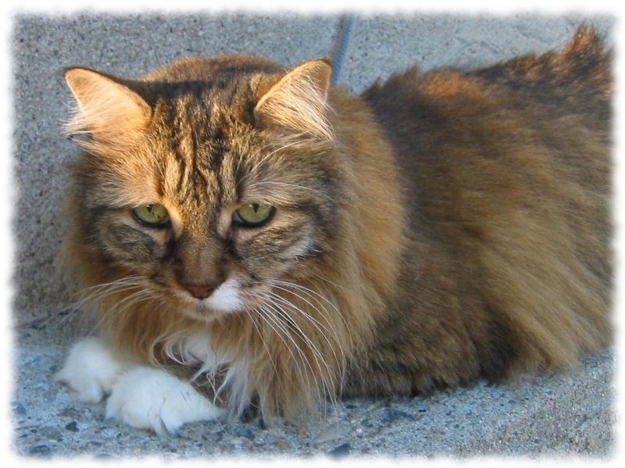
Haiku
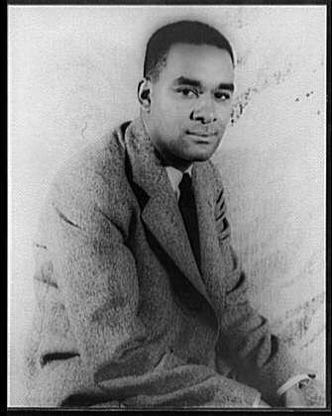
By Richard Wright (1908–1960)
1. | Keep straight down this block,  Then turn right where you will find  A peach tree blooming. | 2. | The dog’s violent sneeze  Fails to rouse a single fly  On his mangy back.
3. | The webs of spiders  Sticking to my sweaty face  In the dusty woods. | 4. | A huge drift of snow  Blocks the narrow pathway to  The little toy shop.
5. | Just enough of snow  For a boy’s finger to write  His name on the porch. | 6. | A butterfly makes  The sunshine even brighter  With fluttering wings.

By James William Hackett (1929–2004)
7. | Beyond this mountain,  so vast as to strain the eye:  a world of autumn. | 8. | Deep within the stream  the huge fish lie motionless,  facing the current.

By Therese Sellers
9. | I was of his life  The sunshine, he said, and left  Through an airport gate. | 10. | Her best poems sprang  Like the winged, immortal horse  Out of blood and loss.

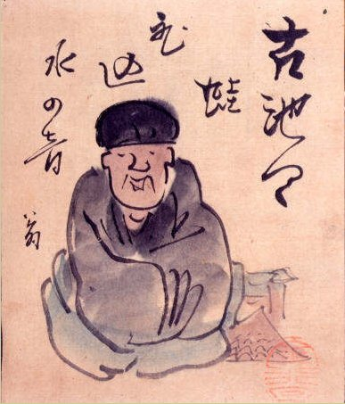
By Matsuo Basho (1644–1694)
11. | old pond—  a frog jumps in,  water’s sound | 12. | one who breakfasts  with morning glories:  that’s what I am
13. | in the capital:  ninety-nine thousand people  blossom viewing | 14. | autumn wind  through an open door—  a piercing cry
15. | wind from Mt. Fuji—  carrying it in my fan,  a souvenir for those in Edo | 16. | ah spring, spring,  great is spring,  etcetera

Rhyme
Two words rhyme when they end with the same sound. Here are some examples.
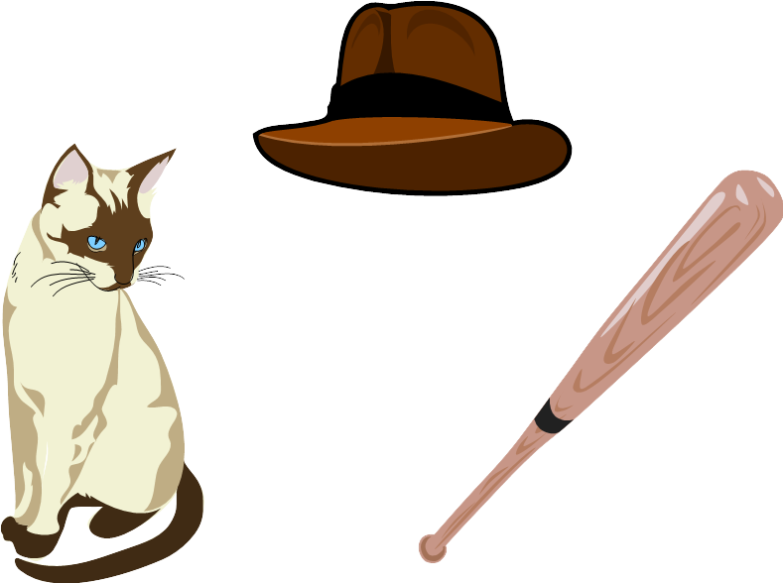
- bat / cat / chat / fat.
- bloody / buddy / muddy / study.
- crane / entertain / remain / Spain.
- beat / neat / sweet / worksheet.

Endymion
Read the poem and find the two pairs of lines that end with rhymes.
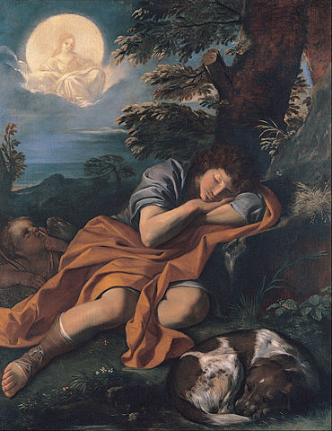A thing of beauty is a joy for ever:
Its loveliness increases; it will never
Pass into nothingness; but still will keep
A bower quiet for us, and a sleep
Full of sweet dreams, and health, and quiet breathing.
– John Keats, Endymion

Find the Rhymes
Circle the words that rhyme with the underlined word.
- Dr. Seuss: Brown came back with Mr. Black.
- P!nk: Right from the start, you were a thief – you stole my heart.
- Eminem: He's nervous, but on the surface he looks calm and ready.
- Taylor Swift: So hey, let's be friends. I'm dying to see how this one ends.
- Alex & Sierra: This is where it starts tonight if you open up your heart tonight.

Brainstorm Rhyming Words
Write words that rhyme.
Example | heart | start | smart | dart | depart
1. | pick | sick | __________ | __________ | __________
2. | hit | pit | __________ | __________ | __________
3. | yes | chess | __________ | __________ | __________
4. | feel | kneel | __________ | __________ | __________

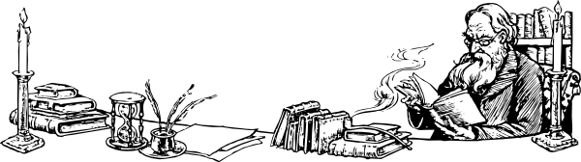
Rhythm
A painter, who lived in Great Britain,
Interrupted two girls with their knittin'
He said, with a sigh,
"That park bench – well I
Just painted it, right where you're sittin'.'"
There was an old man with a beard,
Who said, "It is just as I feared!—
Two owls, an eagle,
A chicken and seagull,
Have all built their nests in my beard!"
These two poems are limericks. Answer the questions.
- How many syllables are in each line?
  - First limerick. 1. ___ 2. ___ 3. ___ 4. ___ 5. ___
  - Second limerick. 1. ___ 2. ___ 3. ___ 4. ___ 5. ___
- Find the lines that rhyme.
  - First limerick. ____ & ____ & ____ ____ & ____
  - Second limerick. ____ & ____ & ____ ____ & ____
- What are some differences between haiku and limericks?

Changing Speed
I have a Gumbie Cat in mind, her name is Jennyanydots;
Her coat is of the tabby kind, with tiger stripes and leopard spots.
All day she sits upon the stair or on the steps or on the mat:
She sits and sits and sits and sits—and that's what makes a Gumbie Cat!
– T. S. Eliot, The Practical Book of Cats
- What do you think the made-up word “gumbie” means?
- Read this poem slowly, then quickly. Which sounds better?
- What parts should be read even more slowly or quickly?

Assonance and Consonance
Assonance is the repetition of vowel sounds. Consonance is the repetition of consonant sounds.
Assonance | Consonance
sweet dreams | first and last
twice at night | a worm in a storm
sweeps and cleans | seven sandwiches
depressed and restless | depressed and restless

Classify the Pattern
Do the following sentences include assonance, consonance, or both?
- Kit-Kat. Assonance / Consonance / Both
- Tee-hee. Assonance / Consonance / Both
- Go light a fire. Assonance / Consonance / Both
- Sweet dreams. Assonance / Consonance / Both
- The bus went by. Assonance / Consonance / Both
- Ring around the roses. Assonance / Consonance / Both
- Deep within the stream. Assonance / Consonance / Both
- Its loveliness increases. Assonance / Consonance / Both


Write Some Sentences
Write sentences including assonance.
Example I love driving at high speeds.
Example Take your time and be patient.

Write some sentences using consonance.
Example The boy didn't want to play baseball.
Example I never read the newspaper on Thursday.

Repetition
Three Rings for the Elven-kings under the sky,
Seven for the Dwarf-lords in halls of stone,
Nine for Mortal Men, doomed to die,
One for the Dark Lord on his dark throne
In the Land of Mordor where the Shadows lie.
One Ring to rule them all, One Ring to find them,
One Ring to bring them all and in the darkness bind them.
In the Land of Mordor where the Shadows lie.
– J. R. R. Tolkien, The Fellowship of the Ring
- What numbers appear in the poem?
- Which two lines are repeated?
- Find the rhyming words.
  - rings &
  - dwarf &
  - die &
  - find &

Poetry Recitation
Choose a poem that you like and read it aloud to the class.
- Start with the name of the poem, if it has one, and the author's name.
- Say when the poem was written, if you know.
- Speak with feeling that matches the words in the poem.
- End with “Thank you.” or a similar closing phrase.

Chapter 2: Shakespeare

1 | All the world's a stage,
 | And all the men and women merely players; | actors
 | They have their exits and their entrances,
 | And one man in his time plays many parts,
5 | His acts being seven ages. At first the infant,
 | Mewling and puking in the nurse's arms.
 | Then, the whining school-boy with his satchel
 | And shining morning face, creeping like snail
 | Unwillingly to school. And then the lover,
10 | Sighing like furnace, with a woeful ballad
 | Made to his mistress' eyebrow. Then, a soldier,
 | Full of strange oaths, and bearded like the pard,
 | Jealous in honour, sudden, and quick in quarrel, | fight
 | Seeking the bubble reputation
15 | Even in the cannon's mouth. And then, the justice,
 | In fair round belly, with a good capon lined, | fat chicken
 | With eyes severe, and beard of formal cut,
 | Full of wise saws, and modern instances,
 | And so he plays his part. The sixth age shifts
20 | Into the lean and slippered pantaloon, | pants
 | With spectacles on nose and pouch on side,
 | His youthful hose, well saved, a world too wide | leg warmer
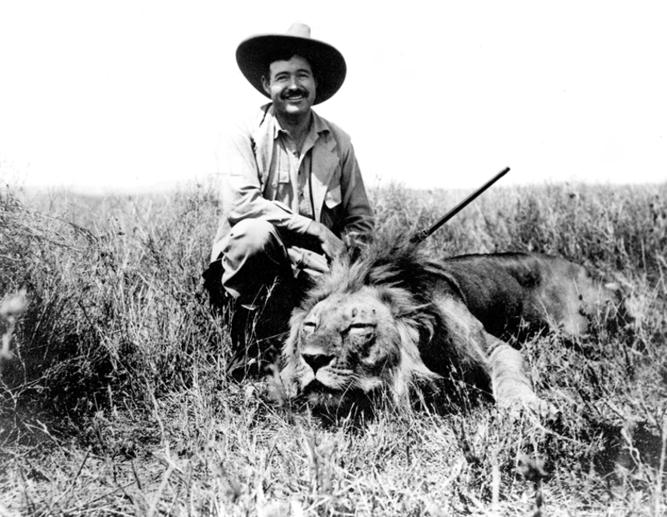  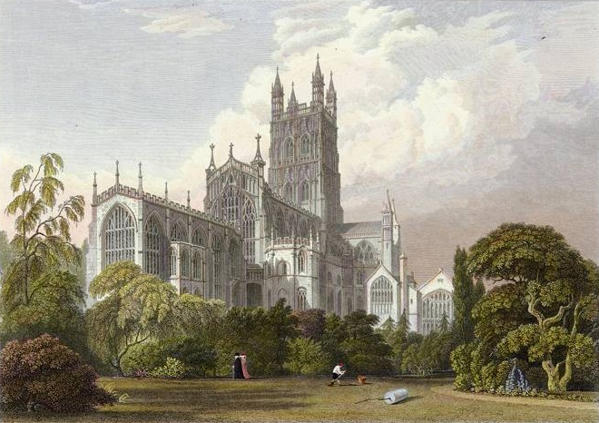 | For his shrunk shank, and his big manly voice, | leg
 | Turning again toward childish treble, pipes | 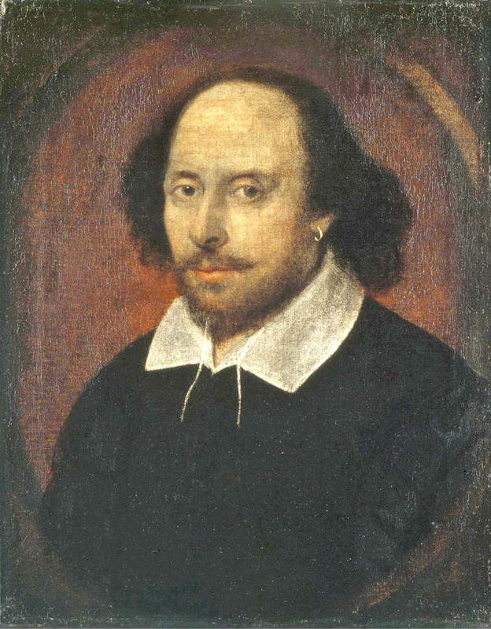
25 | And whistles in his sound. Last scene of all,
 | That ends this strange eventful history,
 | Is second childishness and mere oblivion,
 | Sans teeth, sans eyes, sans taste, sans everything.
– William Shakespeare, As You Like It, Act 2, Scene 7

Ages of Life
Shakespeare says there are seven ages of life. What do people do in each age?
 | Age of life | Years old | Activities for this age
1. | Infant | 0-4 years old
2. | School-boy | 5-14 years old
3. | Lover | 15-18 years old
4. | Soldier | 19-30 years old
5. | Justice | 31-60 years old | Not stated.
6. | Pantaloon | 61-75 years old | Not stated.
7. | Very old person | 76+ years old | Not stated.
shining puking whining mewling sighing creeping seeking

Comprehension Questions
- (Line 4) One man plays only one part. True / False
- (Line 6) A doctor holds the infant. True / False
- (Line 11) The soldier has a beard. True / False
- (Line 15) The justice looks fat. True / False
- (Line 20) The pantaloon is fat. True / False
- (Line 28) In the end, we lose everything. True / False

Unknown Words
The knave pulled a falcata from his belt and slashed at the woman who dextrously jumped to the side. She ran down to the currach, pushed it into the water, and rowed away to safety. High overhead, an egret flew by, not knowing of the chaos unfolding below. With a wrathful yell, the knave stormed back to his burro and led the animal back to town. The burro, though, wanted nothing to do with a footrace and slowly trudged along.
- Cross out all the words you don't know. Use a thick black pen or marker.
- For each word you crossed out, guess at the word's meaning and draw a picture of it.


Chapter 3: Prose

He lay flat on the brown, pine-needled floor of the forest, his chin on his folded arms, and high overhead the wind blew in the tops of the pine trees. The mountainside sloped gently where he lay; but below it was steep and he could see the dark of the oiled road winding through the pass. There was a stream alongside the road and far down the pass he saw a mill beside the stream and the falling water of the dam, white in the summer sunlight.
– Ernest Hemingway, For Whom the Bell Tolls
- Where is the man? A. the city B. the sea C. the countryside
- What time of year is this? A. spring B. summer C. fall
- How tall are the pine trees? A. tall B. short C. average
- What is he looking at? A. the pine trees and sea B. the road and mill
- Does he want to meet anyone? A. yes B. no
Harry Potter was a highly unusual boy in many ways. For one thing, he hated the summer holidays more than any other time of the year. For another, he really wanted to do his homework but was forced to do it in secret, in the dead of night. And he also happened to be a wizard.
– J.K. Rowling, Harry Potter and the Prisoner of Azkaban
- What kind of boy is Harry? A. normal B. brave C. unusual
- When does Harry do homework? A. at night B. at noon C. in the summer
- Does Harry want to study? A. yes B. no C. he doesn't care
- Does Harry like the summer? A. yes B. no C. it's OK
- How many things are unusual? A. 1 B. 2 C. 3

Adjectives and Adverbs
Adjectives are words that modify nouns. Adverbs are words that modify verbs, nouns, and other adjectives.
Adjectives | Adverbs
I want to buy a blue car. | The old man ran slowly.
The water is deep. | The doctor works hard.
Henry was very tired. | The baseball player is really tired.
My mother is angry. | The woman danced gracefully.

Identify the Words
Are the underlined words adjectives or adverbs?
- He walks quickly. Adjective / Adverb
- Your face is red. Adjective / Adverb
- The train stopped suddenly. Adjective / Adverb
- We arrived early. Adjective / Adverb
- He lay flat on the brown, pine-needled floor of the forest.
  - flat Adjective / Adverb
  - brown Adjective / Adverb
  - pine-needled Adjective / Adverb
- The mountainside sloped gently where he lay; but below it was steep.
  - gently Adjective / Adverb
  - steep Adjective / Adverb


Choose the Word
Write the best word in the blank. Which is needed, an adjective or an adverb?
- The bullet train is ________________. [ fast / quickly ]
- He ________________ held the baby. [ gentle / gently ]
- She has ________________ arms. [ thin / thinly ]
- The airplane flies ________________ in the sky. [ high / highly ]

Removing Modifiers
Cross out all adjectives and adverbs in the following sentences.
Example The big dog ran towards the little scared boy.
Example The brown fox quickly jumped over the lazy dogs.
- The teacher carefully carried the heavy books into the noisy classroom.
- The white cat slept lazily on the sunny windowsill.
- The man happily made a tasty cup of coffee for his wonderful wife.
- The man quickly made a cup of black coffee for his busy wife.

Adding Modifiers
Re-write the following sentences. Add an adjective and an adverb to each.
Example The man read the newspaper.
The old man slowly read the newspaper.
- The bird sang.

- The girl threw a baseball to her father.

- Zoe went for a walk in the park.

- Justin answered the question.

Book Report
Choose a paragraph from a book that you like. Introduce it to the class.
- Presentations should be one to two minutes long.
- Start with the name of the book, the author's name, and when it was written.
- Read the paragraph.
- Explain why you like the paragraph.
- End with “Thank you.” or a similar closing phrase.

Comparisons
In English literature and poetry, two common comparisons are used: simile and metaphor. A simile is a comparison using “like” or “as”. A metaphor is a comparison where you say something is something else.
Simile | Metaphor
Your eyes are like deep pools. | That man is a pig.
She was like an angel to me. | Her eyes were fireflies.
Her hair was as soft as silk. | The classroom was a zoo.
He fought like a lion. | My brother is a rolling stone.

Metaphors in Action
Find three metaphors in the poem. Underline them.
The wind was a torrent of darkness among the gusty trees.
The moon was a ghostly galleon tossed upon cloudy seas.
The road was a ribbon of moonlight over the purple moor,
And the highwayman came riding—
Riding—riding—
The highwayman came riding, up to the old inn-door.
– Alfred Noyes, The Highwayman
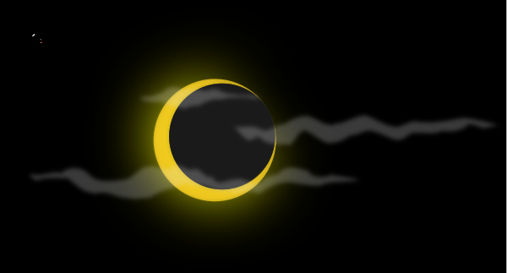

Identify the Comparison
Is each comparison a simile or a metaphor?
- You cry like a baby! Simile / Metaphor
- Baby, you're a firework. Simile / Metaphor
- All the world's a stage. Simile / Metaphor
- His clothes were white as snow. Simile / Metaphor
- Jeff wandered lonely as a cloud. Simile / Metaphor
- Life is a journey, not a destination. Simile / Metaphor
- Steve slept like a rock. Simile / Metaphor
- Juliet is the sun. Simile / Metaphor

Complete the Simile
Example He's as as a puppy. [ sad / happy / cute ]
- She's cold as . [ mice / ice / lice ]
- She is as a cat. [ gentle / quick / rich ]
- You and me, we're stuck like . [ scissors / paper / glue ]
- My heart is like an . [ orange / open book / ant ]


Match the Metaphor
Example | anger | → | a fire | a fast car  Spring  a fire  the sun  night
1. | birth | → |  | a fast car  Spring  a fire  the sun  night
2. | a baby's smile | → |  | a fast car  Spring  a fire  the sun  night
3. | death | → |  | a fast car  Spring  a fire  the sun  night
4. | escape | → |  | a fast car  Spring  a fire  the sun  night

Preferred Descriptions
For each picture, which description do you like? What sounds the best to you? Why?
1. | 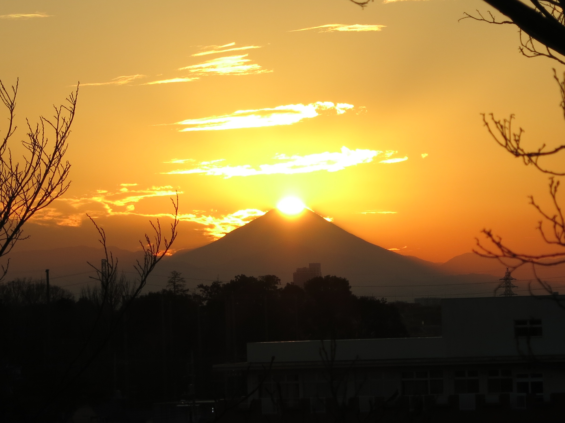 | - The yellow sun set behind Mt. Fuji.  - The sun was a gold halo around Mt. Fuji.  - The sunset on Mt. Fuji was as yellow as corn.
2. | 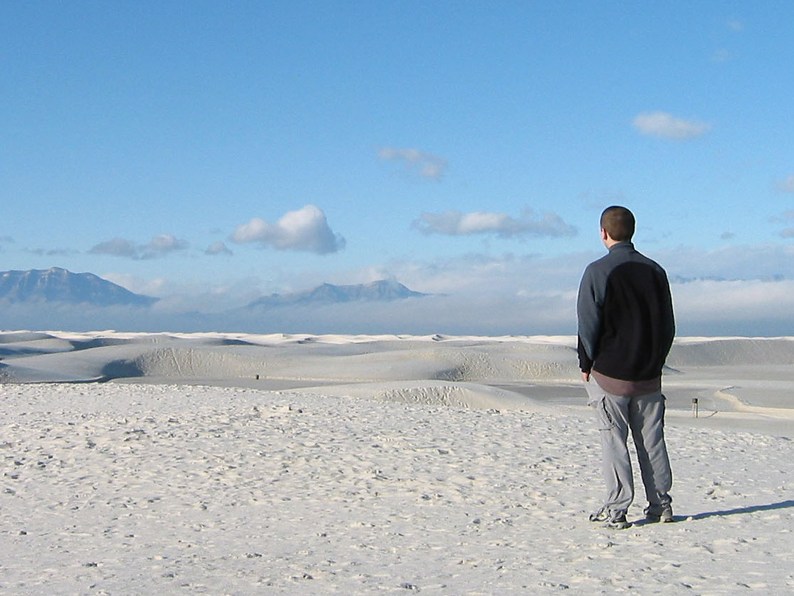 | - It is an ocean of sand.  - The desert sand is as white as snow.  - The desert is wide and the sand is white.
3. | 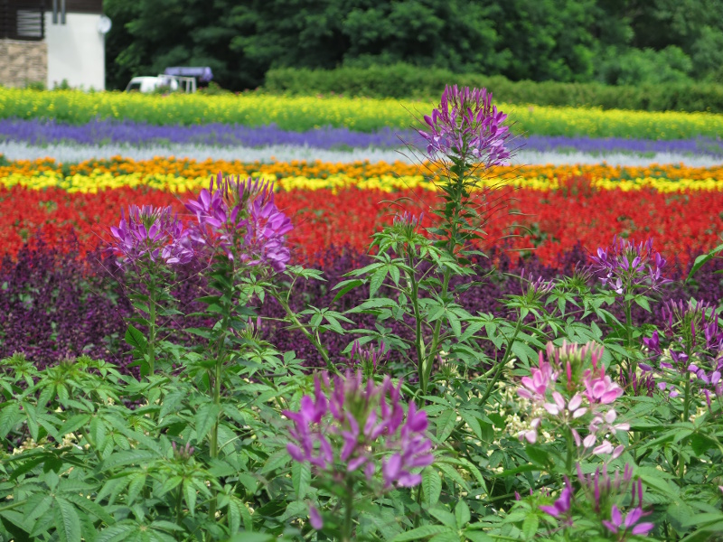 | - The flowers are very colorful.  - The flower garden is like a rainbow.  - The garden is a prism of beautiful flowers.

Simile to Metaphor
Rewrite each simile as a metaphor. Preserve the general meaning.
Example She's angry as a bear. → She's an angry bear.
Example Her hair is soft like a cloud. → Her hair is a soft cloud.
- Your eyes are like deep pools. →
- My uncle is as big as an elephant. →
- He was like a father to me. →
- His car is as slow as a turtle. →
- She's pretty like a princess. →
- Jon is strong like an elephant. →

Choosing a Metaphor
That was a memorable day to me, for it made great changes in me. But, it is the same with any life. Imagine one selected day struck out of it, and think how different its course would have been. Pause you who read this, and think for a moment of the long chain of iron or gold, of thorns or flowers, that would have bound you, but for the formation of the first link on one memorable day.
– Charles Dickens, Great Expectations
- Why do you think the author use the words “iron”, “gold”, “thorns”, and “flowers”?
- Can you think of days in your own life that are as important as this one?

Describe the Pictures
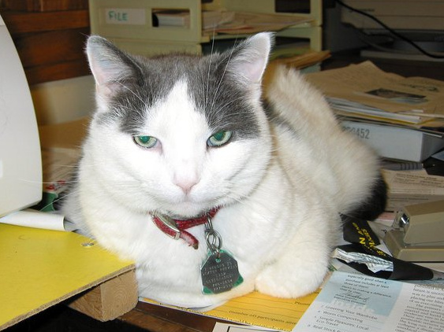  1. | 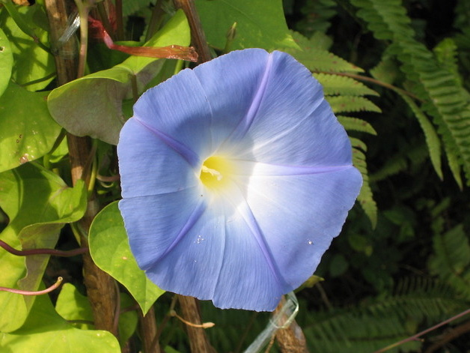  2. | 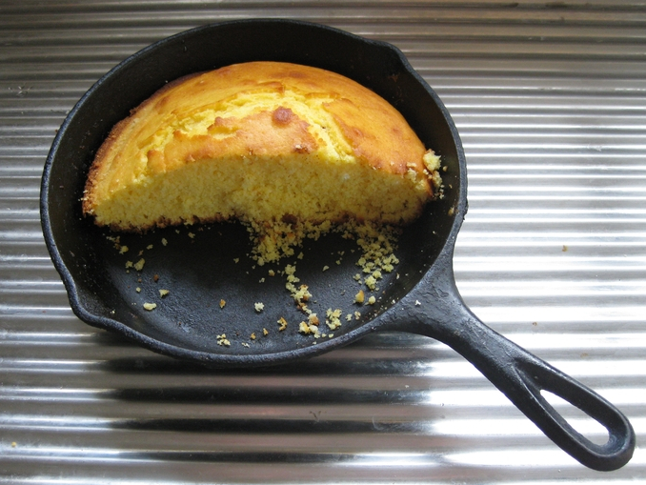  3.
Describe each picture. Use similes or metaphors.

Bibliography

As You Like It. William Shakespeare. 1599.
https://www.gutenberg.org/ebooks/2244
A Book of Nonsense. Edward Lear. 1846.
https://www.gutenberg.org/ebooks/13646
The Catcher in the Rye. J.D. Salinger. 1951.
The Complete Short Stories of Ernest Hemingway. Ernest Hemingway. Scribner, 1987.
Endymion. John Keats. The Poetical Works of John Keats, 1884.
http://www.bartleby.com/126/32.html
The Fall of Hyperion. John Keats. 1819.
https://en.wikisource.org/wiki/The_Fall_of_Hyperion:_A_Dream
The Fellowship of the Ring. J. R. R. Tolkien. George Allen & Unwin, 1954.
For Whom the Bell Tolls. Ernest Hemingway. Scribner, 1940.
Great Expectations. Charles Dickens. Chapman & Hall, 1861.
https://www.gutenberg.org/ebooks/1400
Haiku etc. Therese Sellers. 2010-2015.
http://theresesellers.org/?page_id=650
The Haiku Form. Joan Giroux. Tuttle Publishing, 1974.
Haiku: This Other World. Richard Wright. Arcade Publishers, 1998.
Harry Potter and the Prisoner of Azkaban. J. K. Rowling. Bloomsbury, 1999.
The Highwayman. Alfred Noyes. 1906.
http://www.poetryfoundation.org/poem/171940
Letters of John Keats to His Family and Friends. John Keats. 1891.
https://www.gutenberg.org/ebooks/35698
Old Possum's Practical Book of Cats. T. S. Eliot. Faber and Faber, 1939.
http://www.moggies.co.uk/html/oldpssm.html

