Fact Sheet Example
December, 2015
Rules
- In small groups, make a short presentation.
- All students must speak.
- Say at least 2 sentences.
- Use some information from the sheet. You can choose what you like.
U.S.A. Fact Sheet
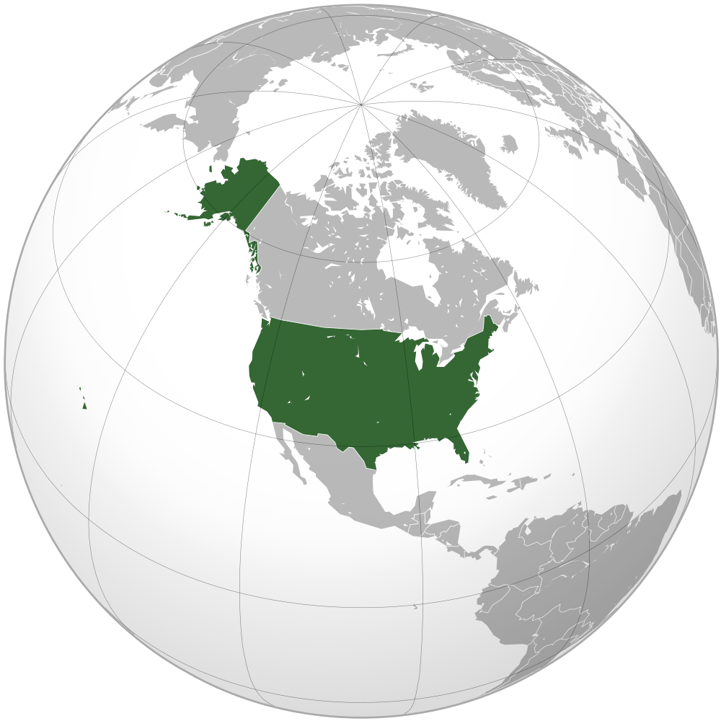 | 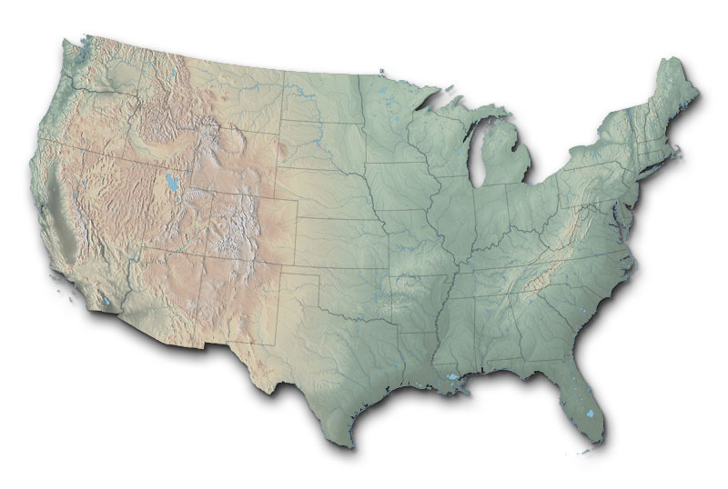
 | Country name 正式国名 | The United States of America
 | Capital 首都 | Washington, D.C.
 | Population 人口 | 316,000,000 people (in 2013)
 | Size | 9,800,000 km² (26x Japan)
 | Languages 言語 | English
 | Common animals | Deer, bear, eagle
 | 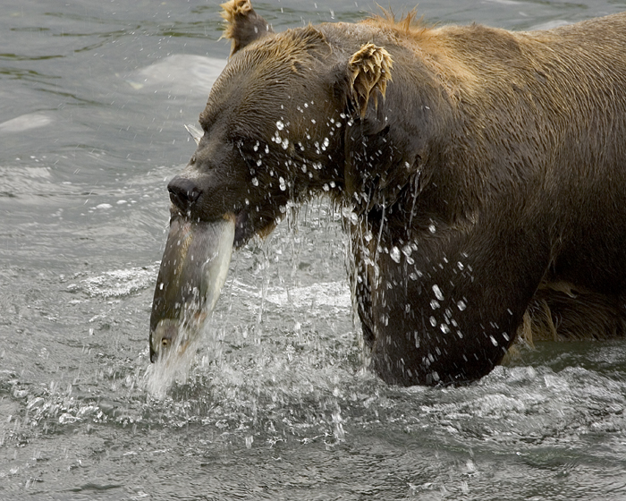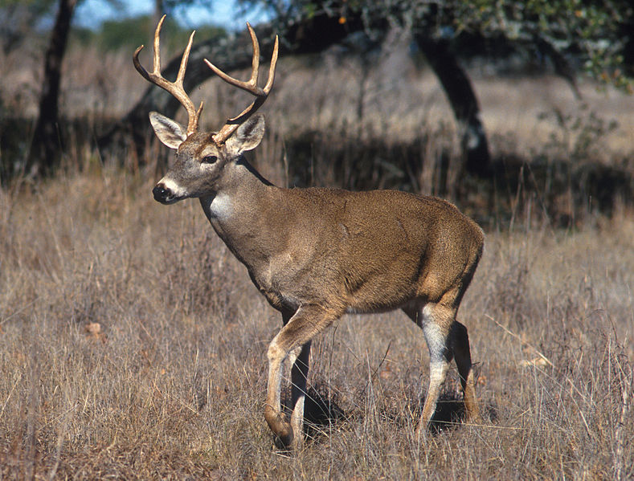
 | Sports | Baseball, football, basketball
 | 
 | Food | Pizza, hamburgers, Mexican food
 | 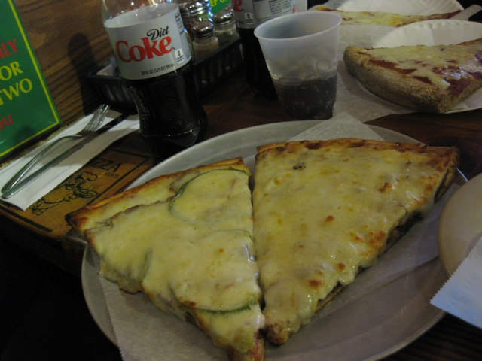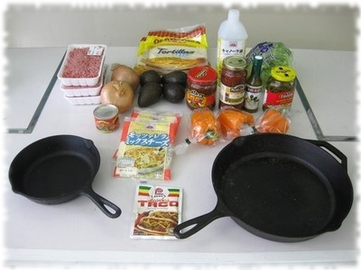
 | Other | 4th largest country in the world  3rd largest population in the world

Example presentation
Today we're going to talk about America.
America is the 4th largest country in the world.
The population is three hundred sixteen million people.
Pizza is a popular food.
Many people like to eat hamburgers, too.
In America, most people speak English.
Some normal sports are baseball, football, and basketball.
Thank you for listening.

